For HOD regarding Academic Calendar
Enter URL 103.91.62.110/lms
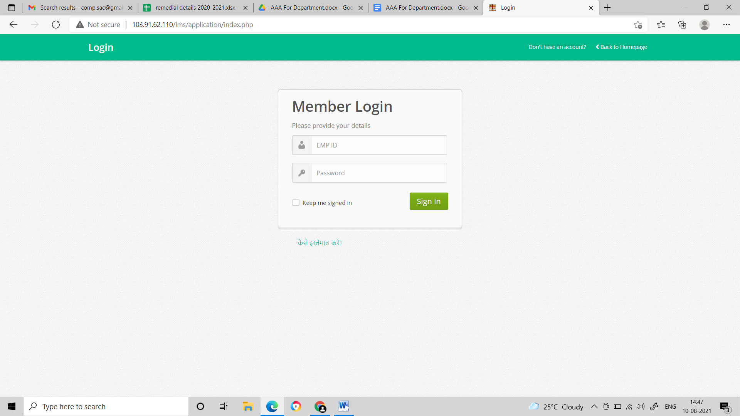

- Enter your employee ID in user id and Password both section

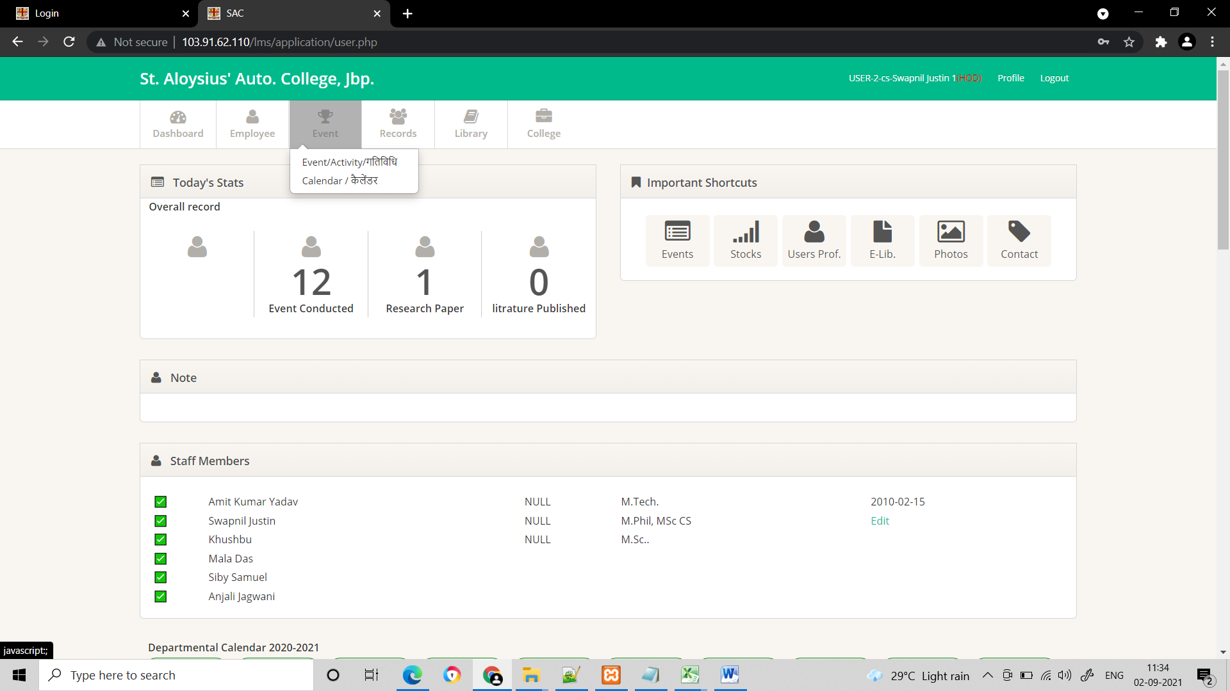
Click

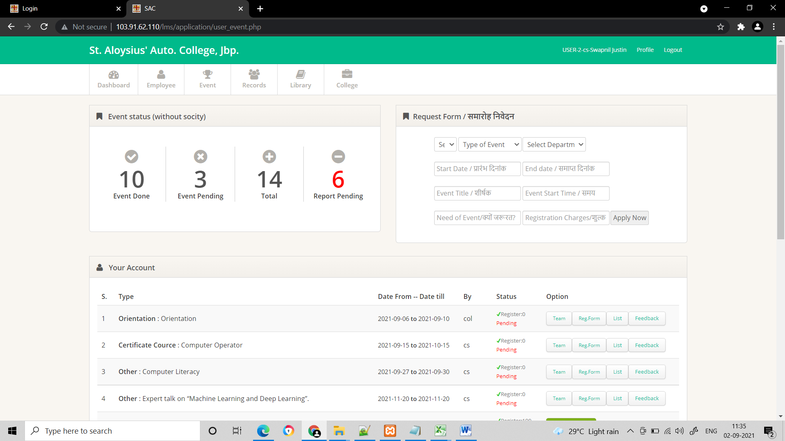
Fill details and click apply

The End

For every Teacher of the department : Updating Personal Profile
Enter URL 103.91.62.110/lms

- Enter your employee ID in user id and Password both section
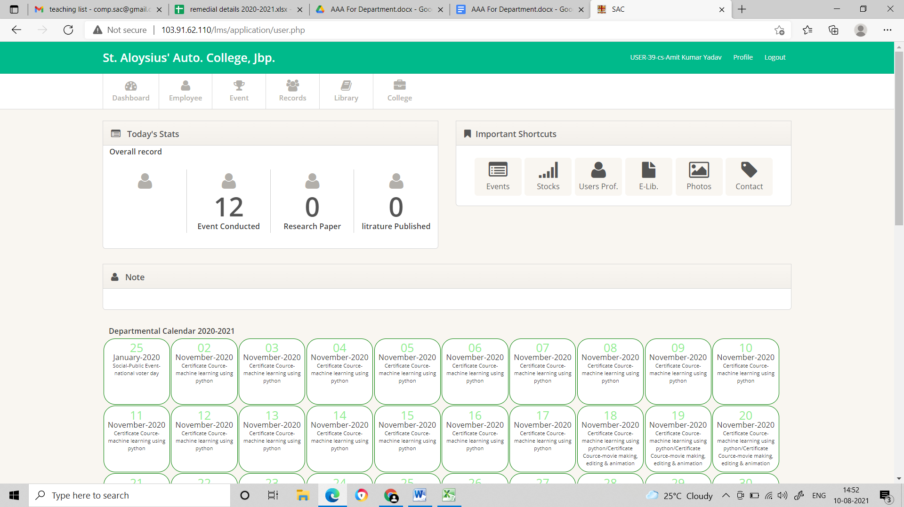
Click Employee
- Choose academic profile from list

Fro Publication entry
FOR EVENT ENTRY
For project

- Fill entries and click SAVE
The End

Updating records for an event steps:
- Add teacher’s duty list in Team button.
- Use reg form for registration.
- Use Feedback button for taking feedback.
- Click event complete button.
- Upload report.
- View report or generate certificate of participation.
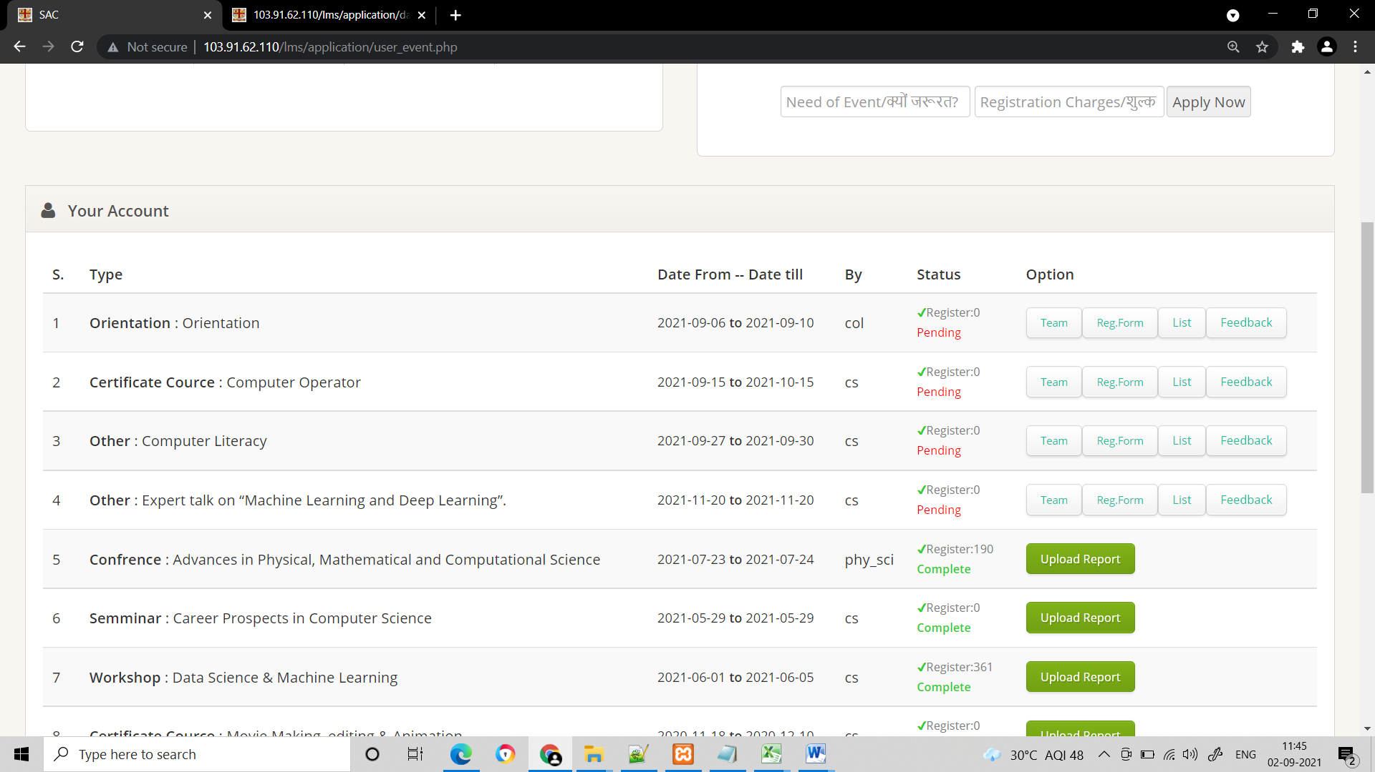
Add Teacher involve in activity
Event Registration form

