SWATCHH BHARAT

REPORT
2019-20

BY

NSS VOLUNTEERS
ST. ALOYSIUS COLLEGE
JABALPUR (M.P.)

ACKNOWLEDGEMENT
WE THANK OUR HONOURABLE PRIME MINISTER SHRI. NARENDRA DAMODAR MODI FOR CONDUCTING SUCH AWARENESS ACTIVITIES.
SECONDLY WE WOULD LIKE TO THANK OUR PRINCIPAL DR.FATHER VAZHAN ARASU, VICE PRINCIPLE DR. KALLOL DAS.
ALSO WE WOULD LIKE TO THANK OUR PROGRAM OFFICERS DR. AKHILESH PATHAK SIR AND DR. ABHILASHA SHUKLA MAM FOR ENCOURAGING AND MOTIVATING US TO TAKE PART IN SUCH A NOBLE WORK. THEIR PRESENCE IS EVER BENEFICIARY AS THEY HAVE BEEN OUR GUIDE AT EVERY STEP.
AT LAST WE WOULD LIKE TO THANK OUR FELLOW VOLUNTEERS AND THE LOCAL PEOPLE FOR MAKING THESE ACTIVITIES A SUCCESS AND CREATING A DIFFERENCE IN THE SOCIETY.

PURPOSE
TO MAKE PEOPLE AWARE OF THE “SWATCHH BHARAT MISSION” AND TO ENCOURAGE THEM TO BE A PART OF THE MISSION

- TO MAKE THEM REALISE THE USE OF “DUSTBINS.”
- ENCOURAGE THEM FOR “AFFORESTATION”.
- TO INCULCATE THE DIGNITY OF WORK AMONG LOCAL RESIDENTS THAT IS THE FEELING “KOI KAM CHOOTA NAHI HOTA”

- TO AWARE THE COMING GENERATION ABOUT THE CHALLENGES THEY MAY FACE IN COMING FUTURE AND HOW TO TACKLE THEM.

MEMBERS INVOLVED
Dr. Akhilesh Pathak (NSS officer Boys Unit St. Aloysius College)
“BOYS”
- SHALEEN NAYYAR
- NITIN PANDEY
- SAKSHAM JAIN
- AYUSH CHANDROL
- PRASANT MISHRA
- SANI SAMUEL
- MOHIL PATEL
- SHIVAM JAISWAL
- MANASVI SHARNAGAT
10.SOURABH CHOURASIA
11.SHOBIT MISHRA
12.ANURAG SONI

MEMBERS INVOLVED
Dr. Abhilasha Shukla (NSS officer Girls Unit)
“GIRLS”
1. CHHAVI TRIPATHY
2. NIKITA PATHAK
3. MAHESWARI DWIVEDI
4. NIRALI PATEL
5. SHRISTI TIWARI
6. SOUMYA TIWARI
7. SNIGDHA MISHRA
8. SHREYA RAJAK

“SWATCHHTA ACTIVITIES”
OF CAMPUS ACTIVITES:
1.“TREE PLANTATION”
WE PLANTED SEVERAL TREES ON 18 AUG 2019 AT PIPARIYA KALAN, JABALPUR. BY THIS WE GAVE THE MESSAGE OF PLANTING TREES AND MAKE OUR ENVIONMENT GREEN AND CLEAN.
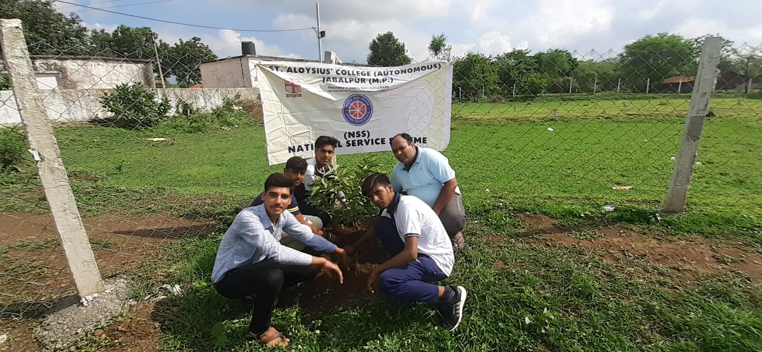
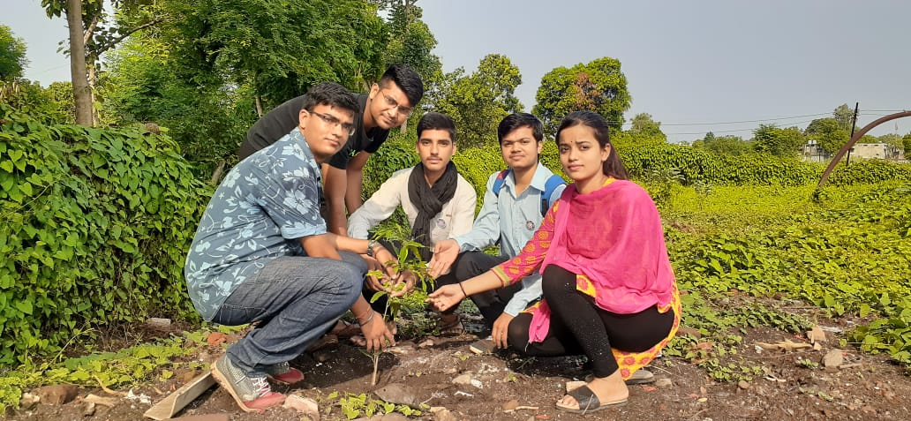

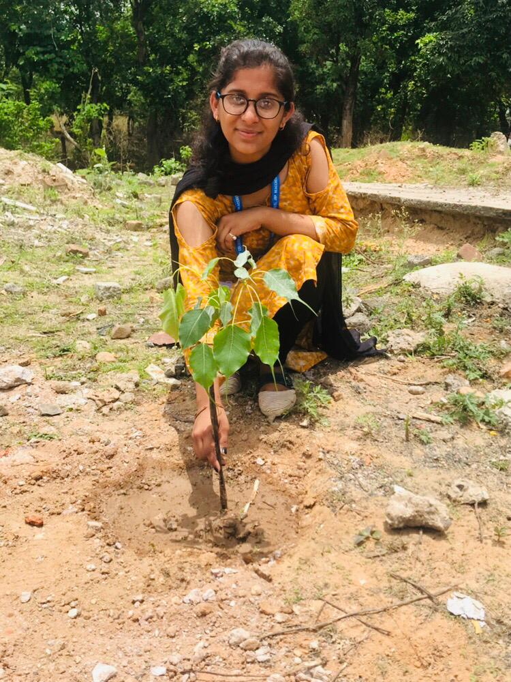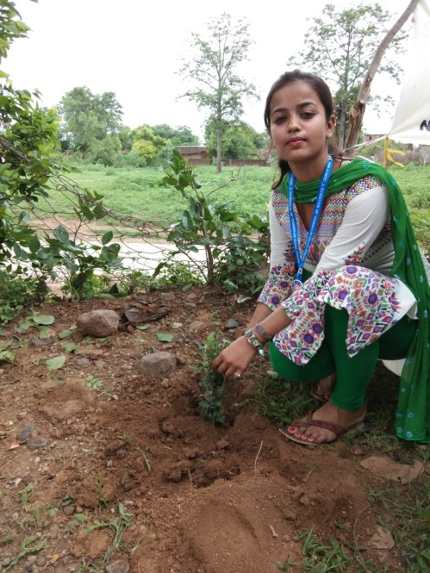

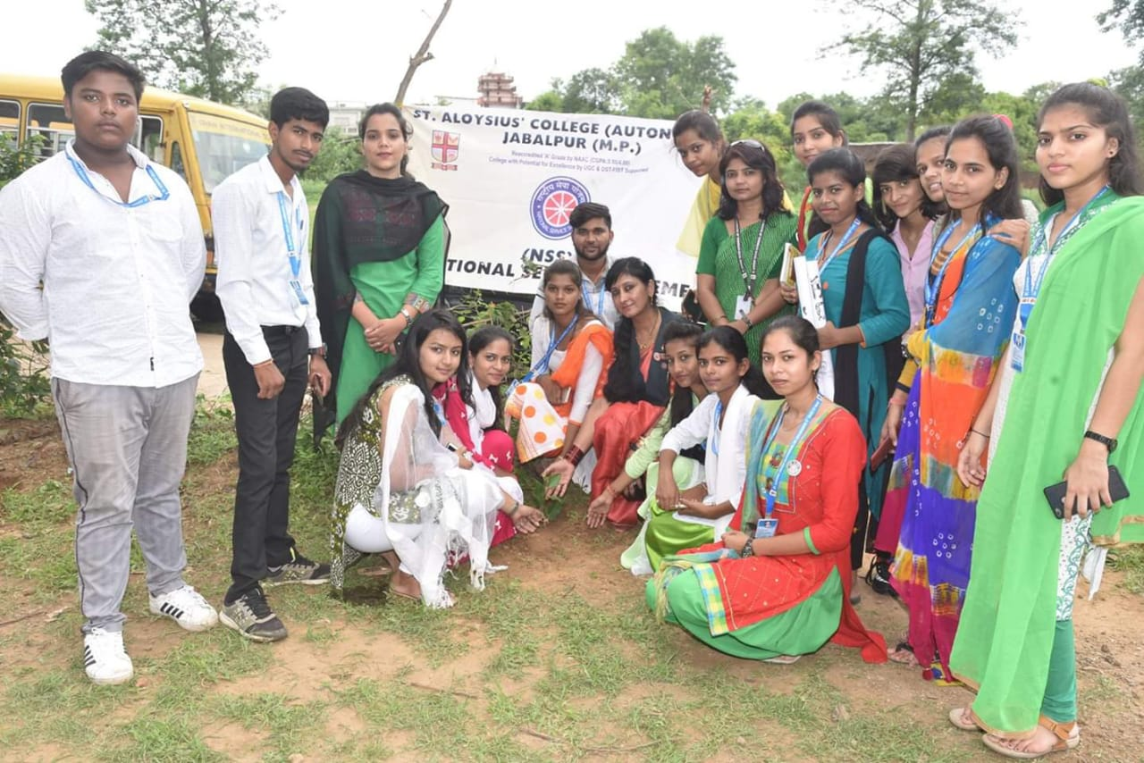

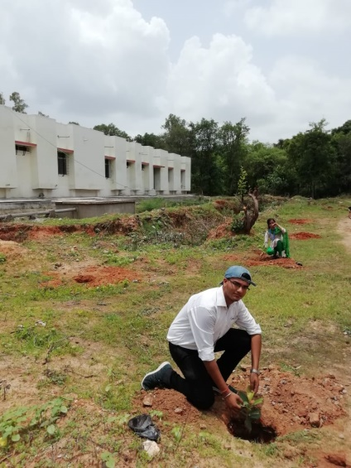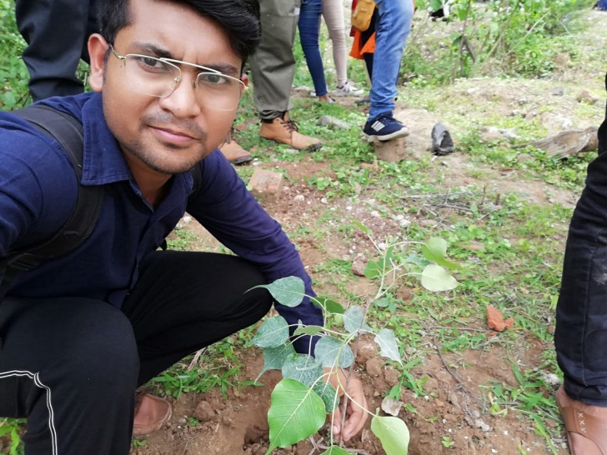
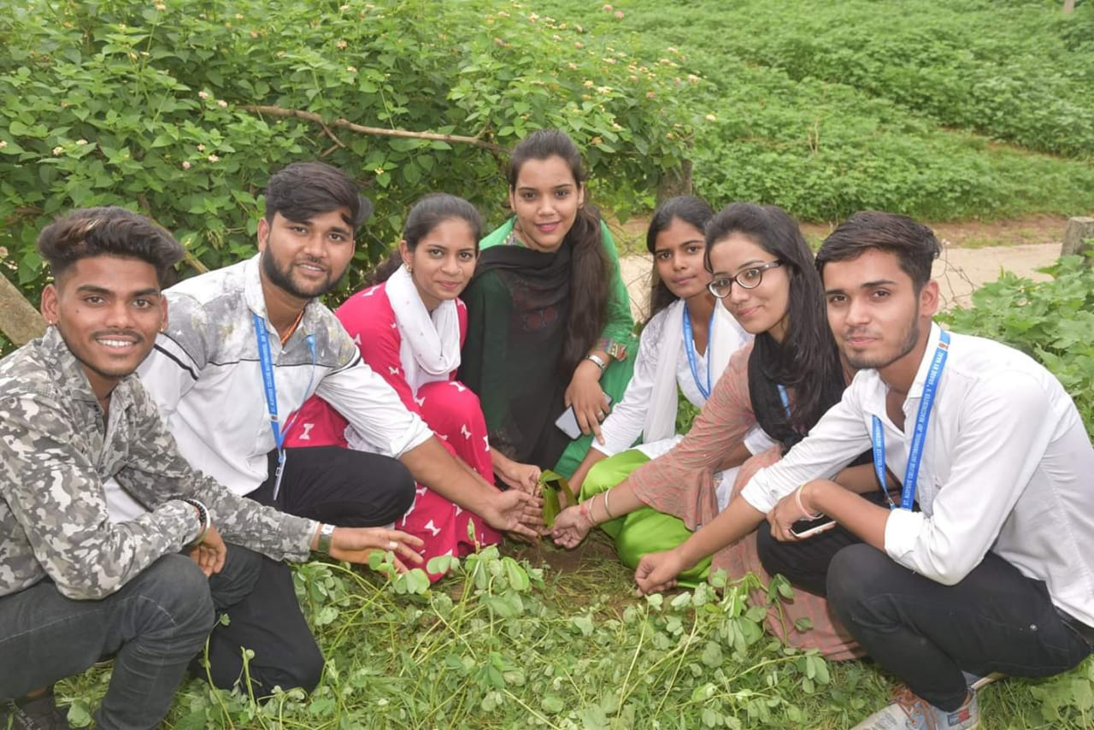
2.“MADE PITS FOR MAKING COMPOSITE MANURE”.
WE HAD MADE A PIT ABOUT 4 FEET DEEP AT PIPARIYAKALA ON 25 AUG 2019, SO THAT THE LOCAL PEOPLE CAN PUT THE VEGETABLE AND FRUIT PEELS INTO IT, WHICH CAN BE TRANSFORMED INTO MANURE.

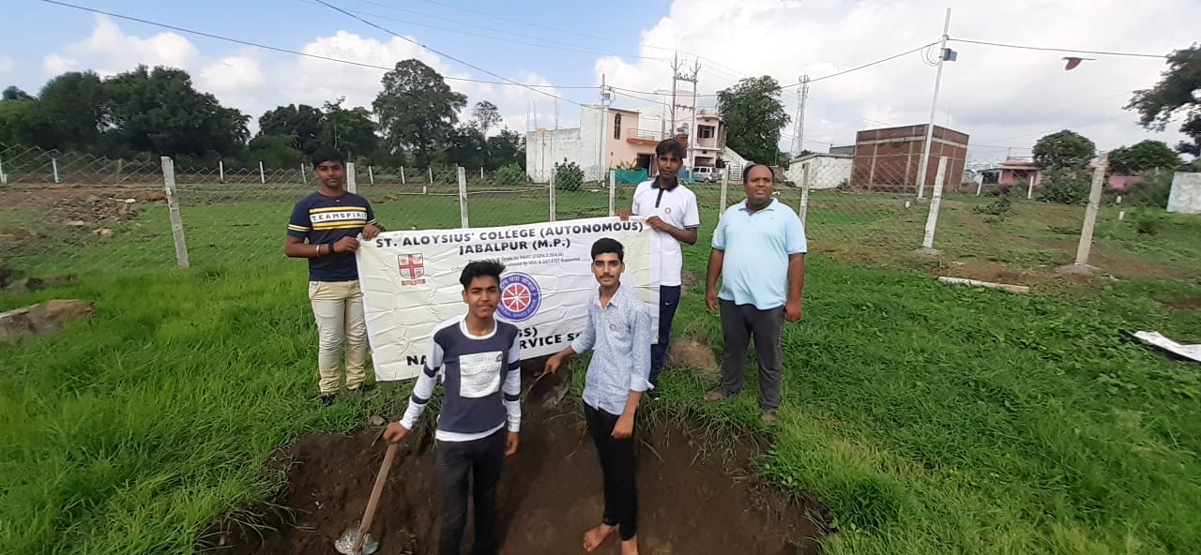

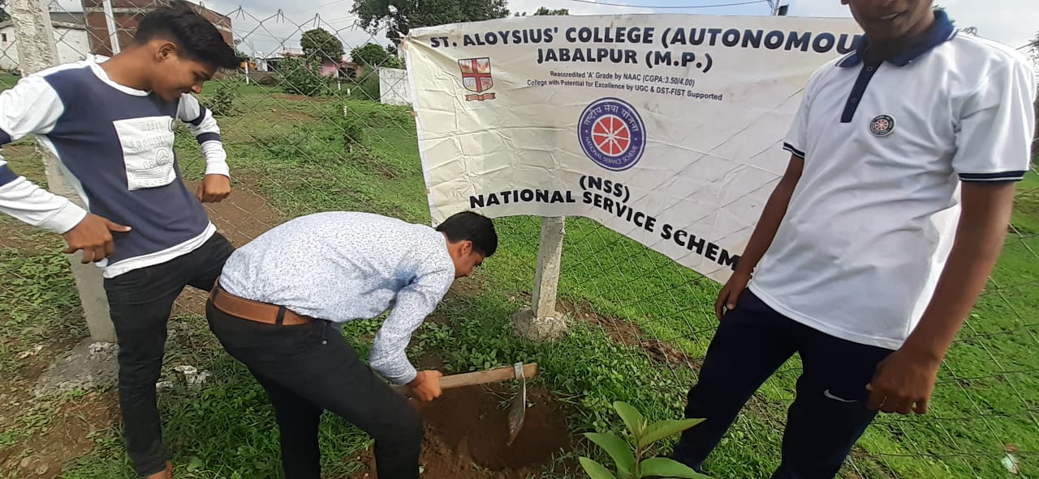

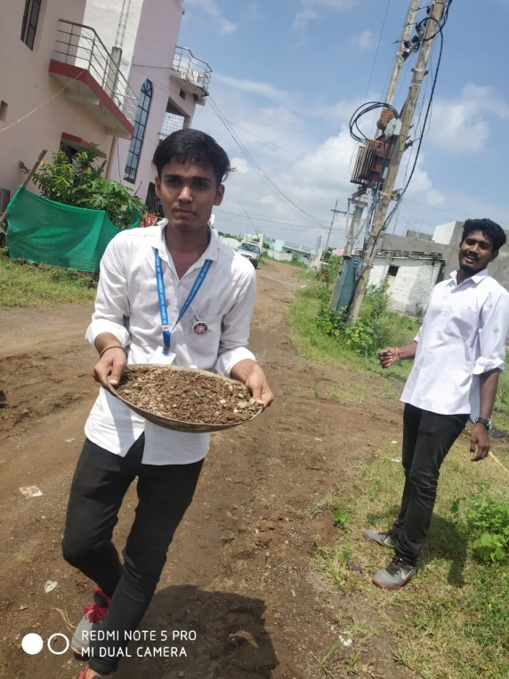

3.”WALL PAINTING”.
TO ENCOURAGE THE LOCAL PEOPLE FOR USING DUSTBIN WE HAD MADE A WALL PAINTING GIVING THEM A MESSAGE FOR THE SAME AT PIPARIYAKALA GOUR JABALPUR GOVERNMENT SCHOOL ON 01 SEP 2019.
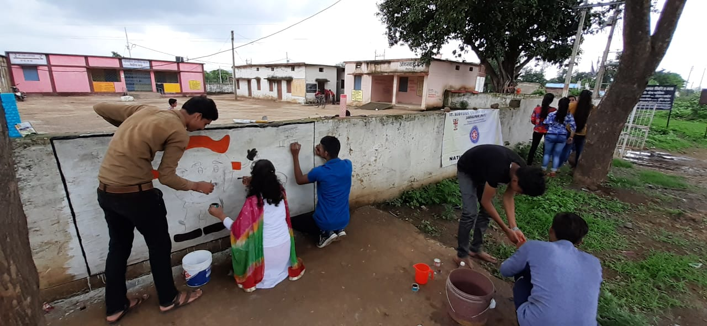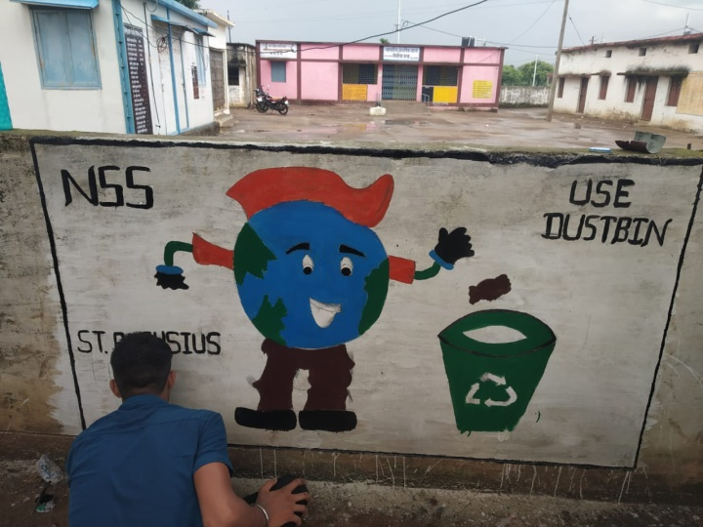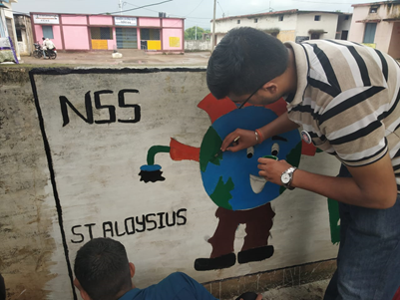
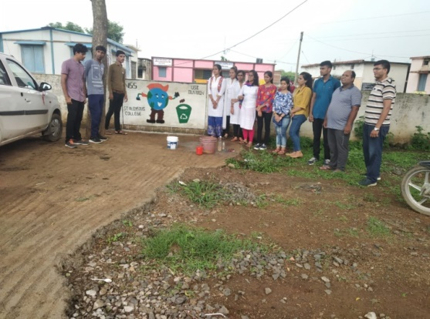
4.”ORGANISE A RALLY”.
FOR PROMOTING THE FEELING OF CLEANLINESS WE HAD ORGANISED A RALLY AT PIPARIYAKALA ON 08 SEP 2019 , GIVING AT THE LOCAL PEOPLE SPECIALLY THE STUDENTS FOR MAKING THE SURROUNDING GREEN AND CLEAN.
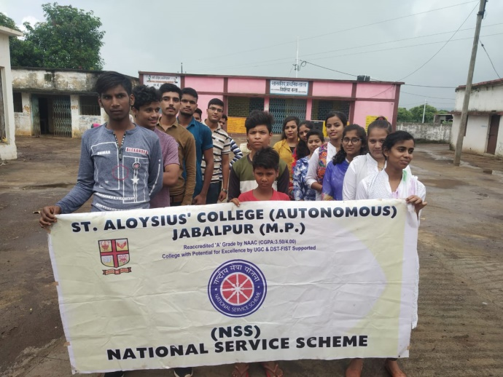
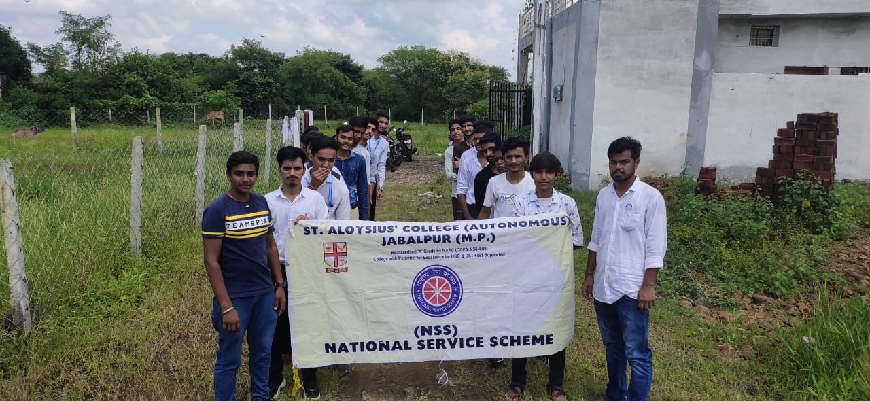

5.“FACE TO FACE COMMUNICATION”
WE HAD ALSO COMMUNICATED WITH THE ELDER PEOPLE GIVING THEM THE MESSAGE FOR GREEN AND CLEAN ENVIRONMENT AND ALSO LADIES FOR USE OF SANITARY PAD.
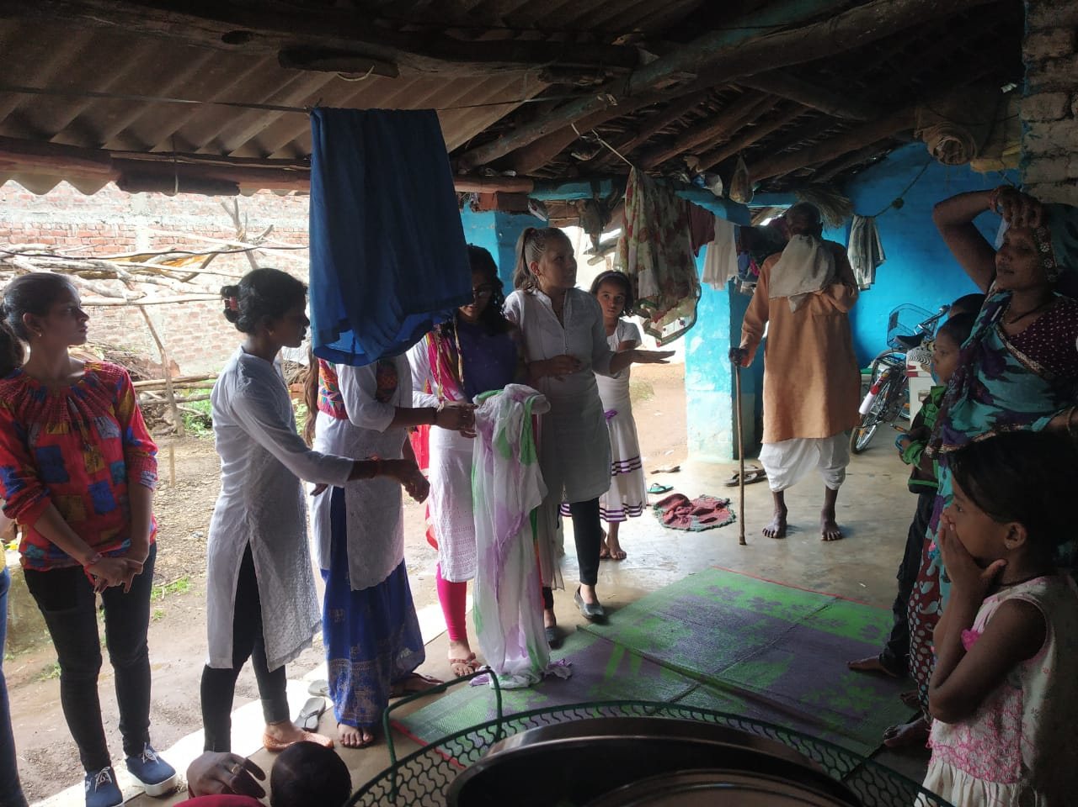

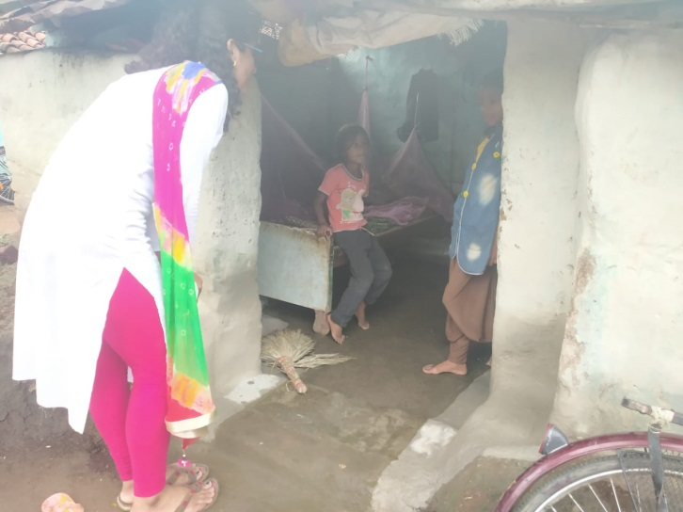

6.”REMOVED MUD FROM ROAD TO MAKE THE TRANSPORT EASY”
THE RAINFALL THIS YEAR HAS MADE SEVERAL RECORDS WHICH ARE BOTH FRUITFUL AS WELL AS HARMFUL FOR US.ON ONE SIDE IT IS A GOOD SIGN FOR THE WINTER CROPS,ON THE OTHER HAND IT MADE THE DAILY LIFE OF LOCAL QUITE DIFFICULT.
WE HAD CLEARED THE WET MUD FROM ROAD THUS MAKING THE TRANSPORT EASY.

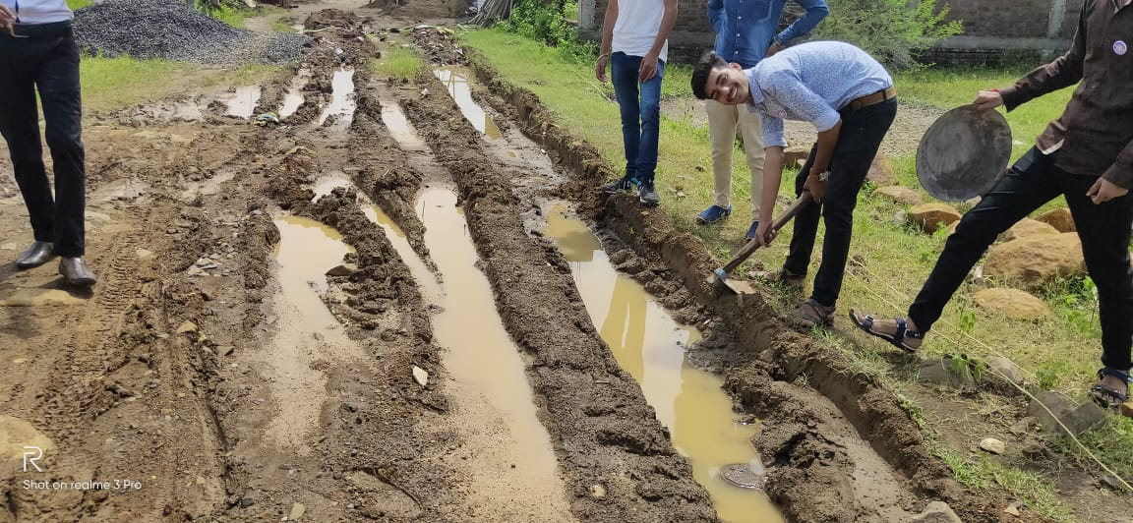
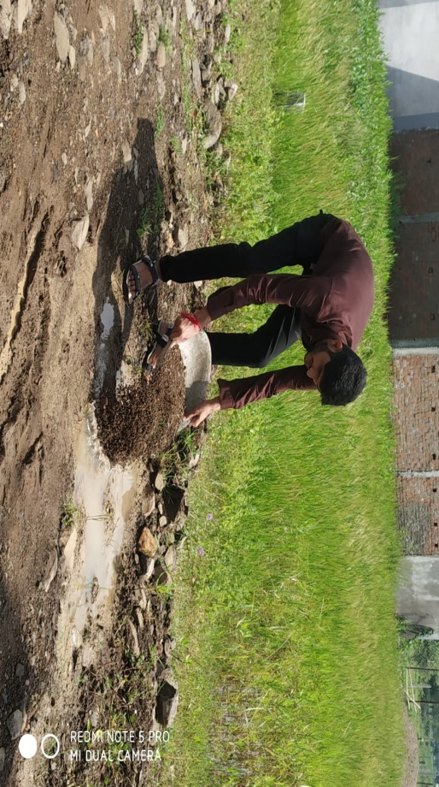
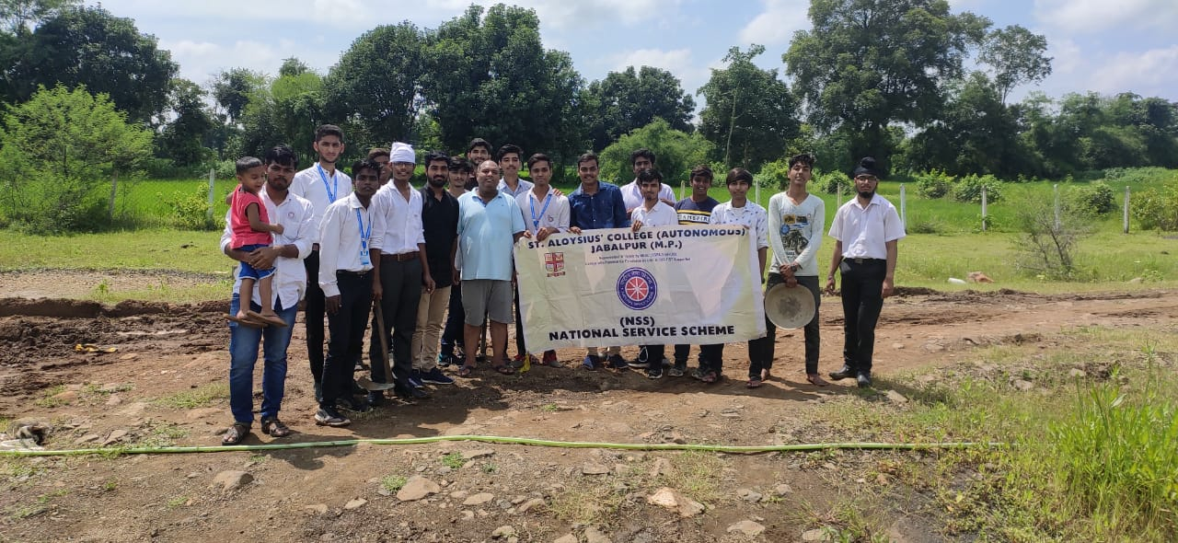
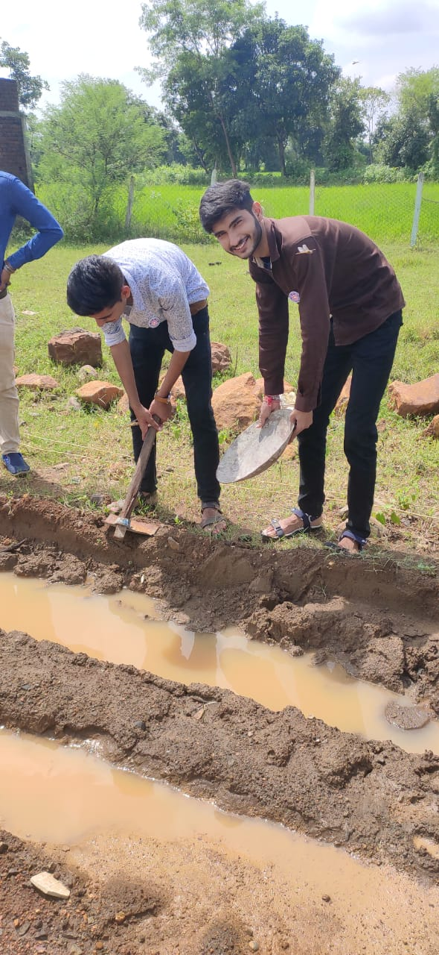

7 “NUKKAD NATAK”
TO EXPLAIN SOMEONE, DRAMA OR STORY IS THE BEST WAY.WE USE THIS TECHNIQUE VERY OFTEN TO TELL THE LOCALS WHAT WE WANT TO SAY.
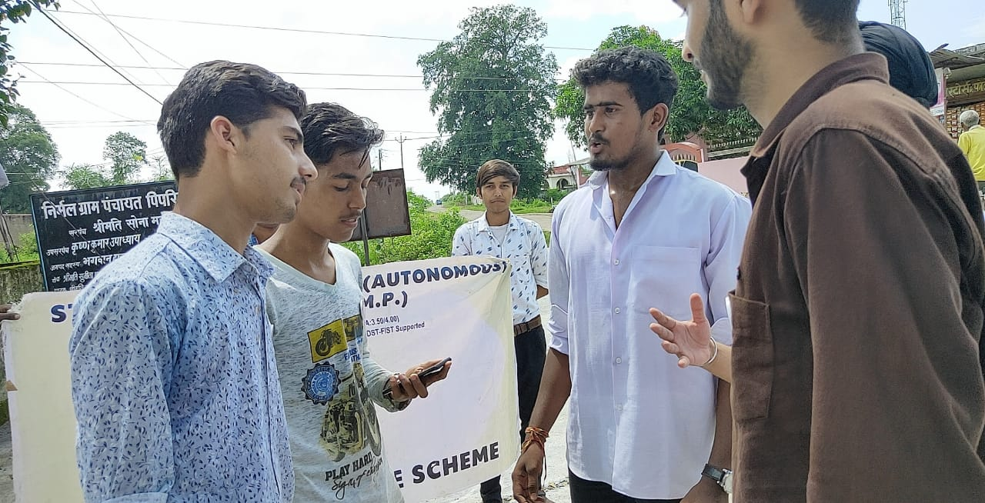
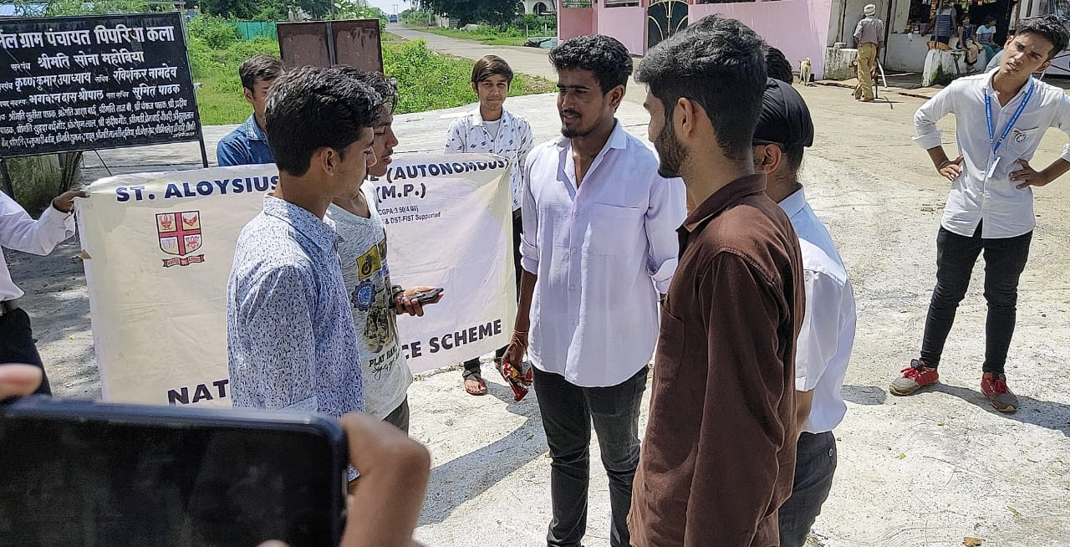

8 “PAPER CUTTINGS”

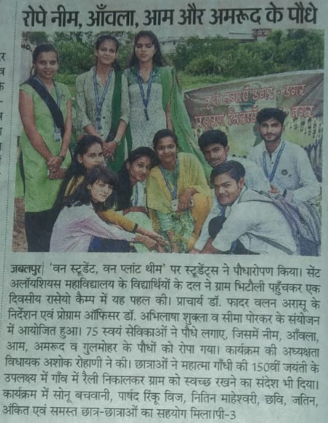
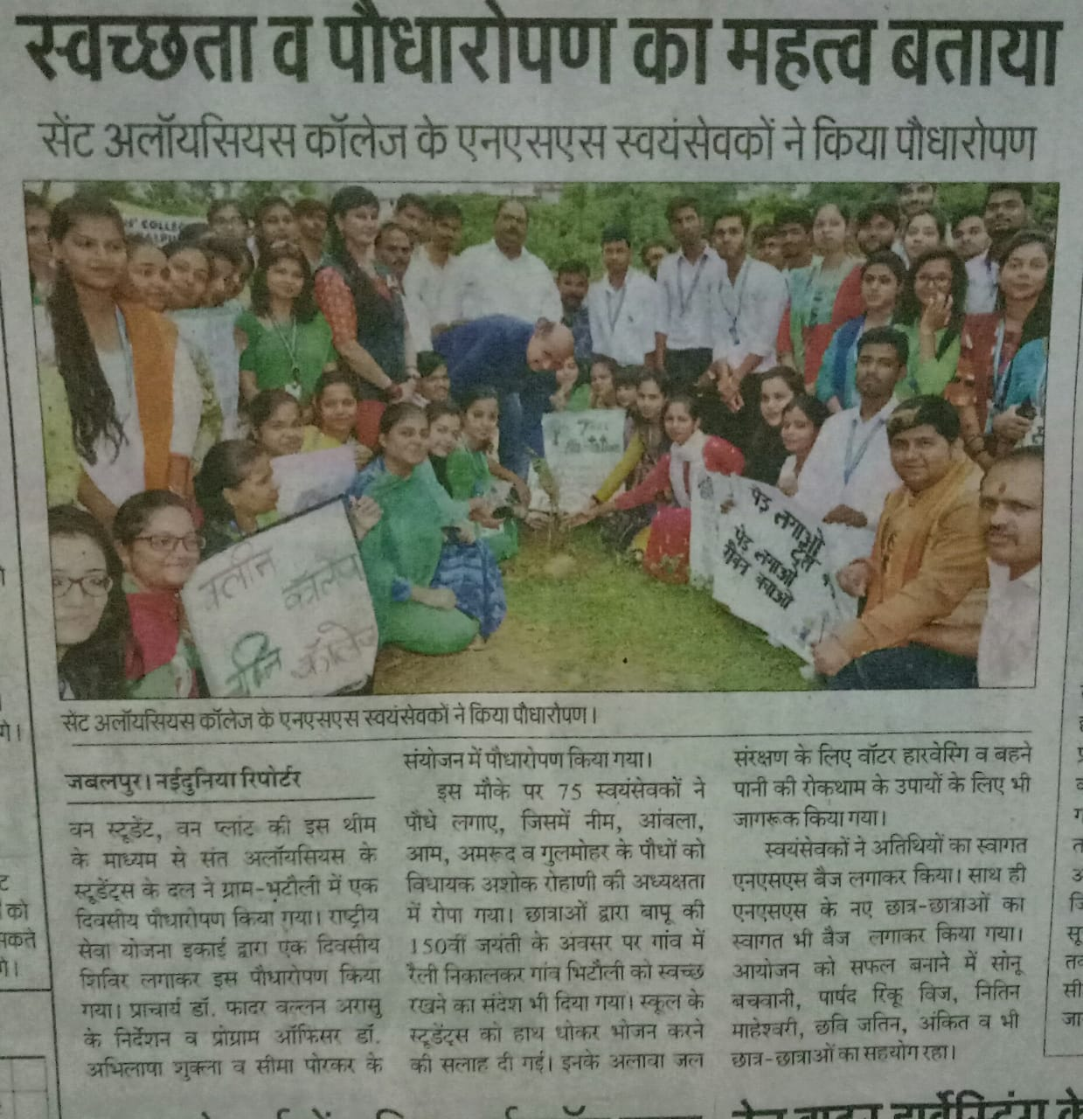

IN CAMPUS ACTIVITIES

9.“ORGANISED CONFERENCE”

A CONFERENCE WAS ORGANISED TO RELATE POSHAN “NUTRITION” AND CLEANLINESS “SWATCHHTA” AT CONFERENCE HALL OF ST. ALOYSIUS COLLEGE ON 21 SEP 2019. THE OUTCOME OF THE CONFERRENCE IS TO DO SOME NEW AND ATTRACTIVE ACTITVITIES TO PROMOTE CLEANLINESS ALONG WITH POSHAN I.E. NUTRITION.
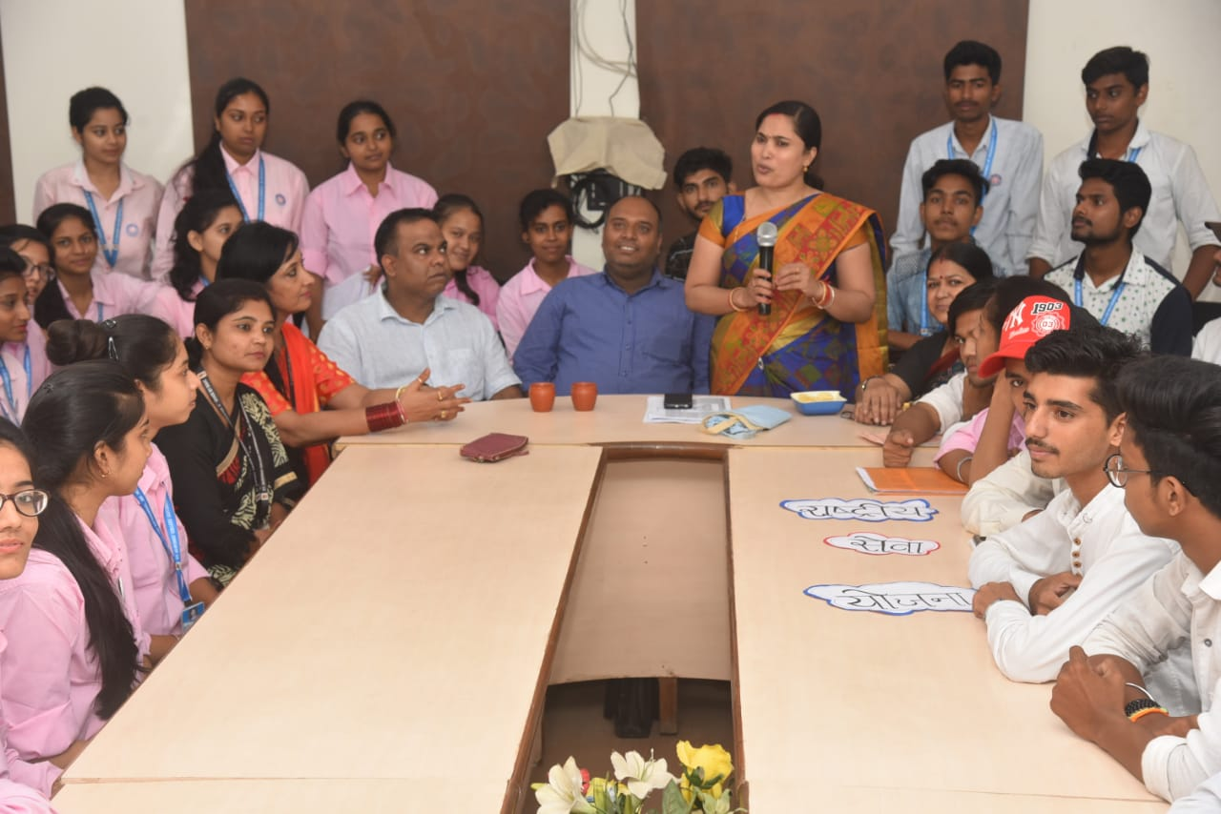
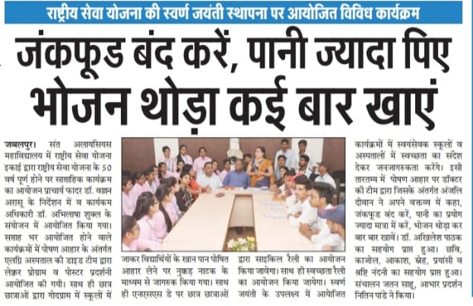

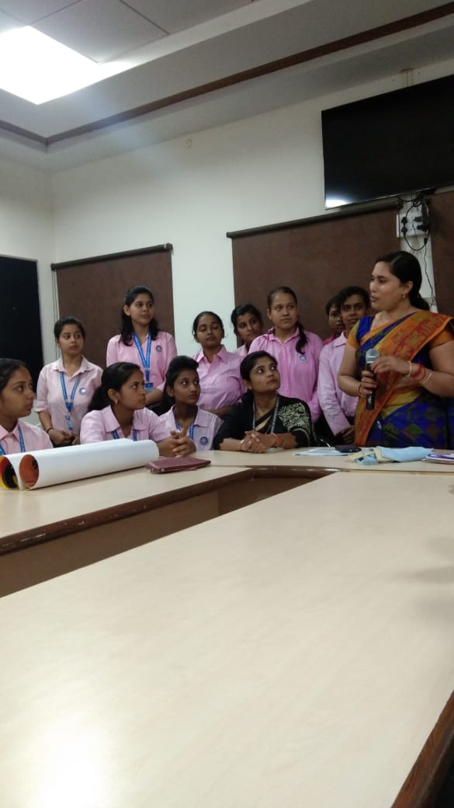

- POSTER COMPETITION ON POLYTHIN FREE ZONE
A POSTER COMPETITION ON POLYTHIN FREE ZONE ON 21 SEP 2019 IN THE CONFERENCE HALL OF ST. ALOYSIUS COLLEGE, JABALPUR.
IN THIS COMPETITION 100 STUDENTS WERE PARTICIPATED.
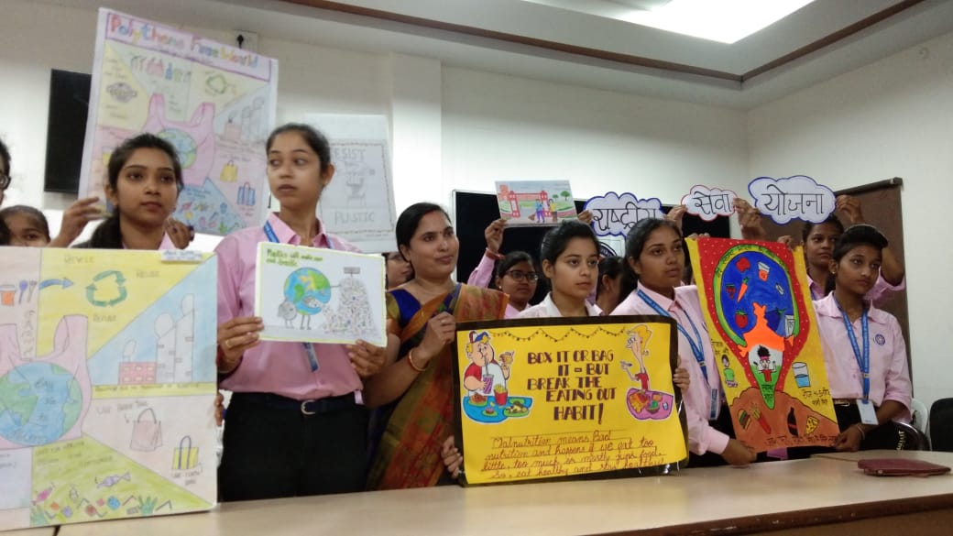

- CYCLE RALLY ON SWACHATA:
NSS UNIT OF ST. ALOYSIUS COLLEGE, JABALPUR ORGANIZED A CYCLE RAILLY ON SWACHATA AND FREE POLYTHIN ZONE ON 24 SEP 2019 IN COLLEGE CAMPUS.
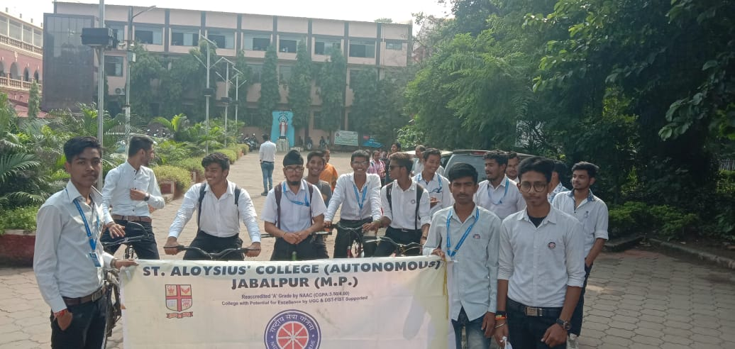
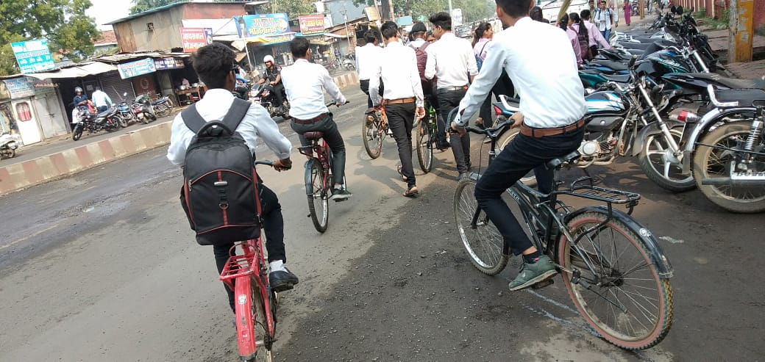
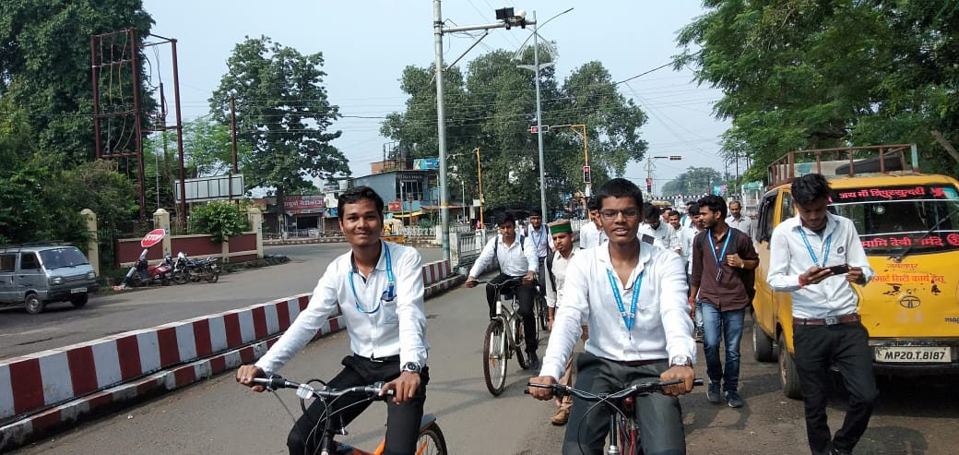
- SKIT ON FREE POLYTHIN ZONE:
NSS UNIT ORGANIZED A SKIT ON FREE POLYTHIN ZONE IN THE CAMPUS ON 24 SEP 2019.
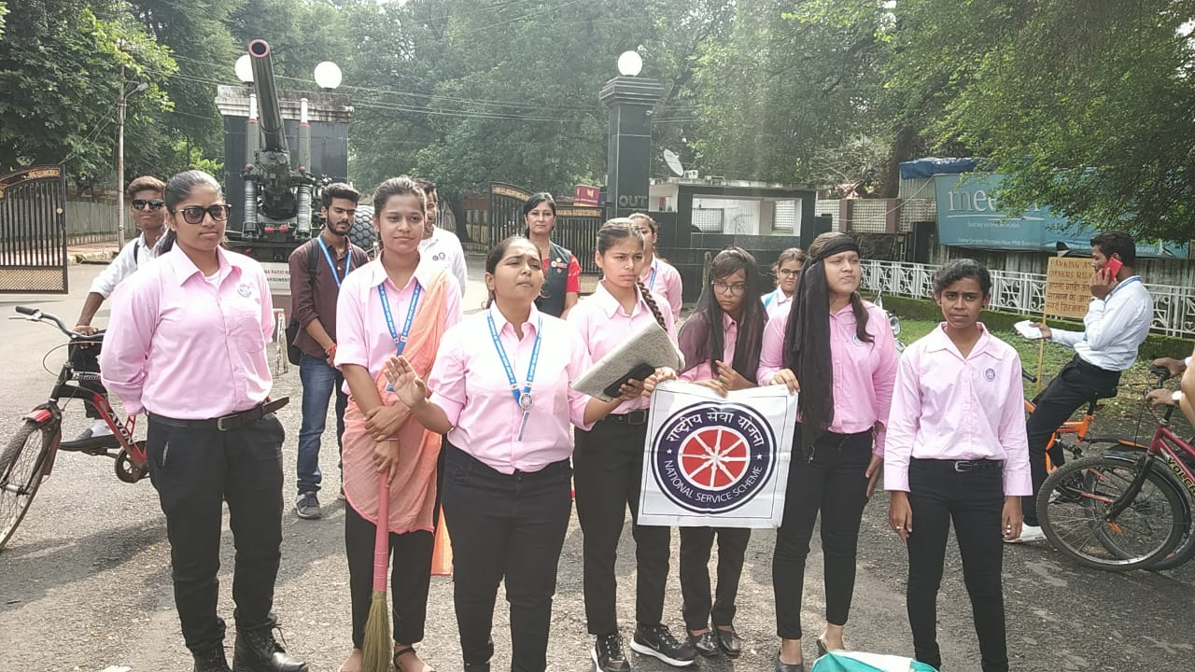
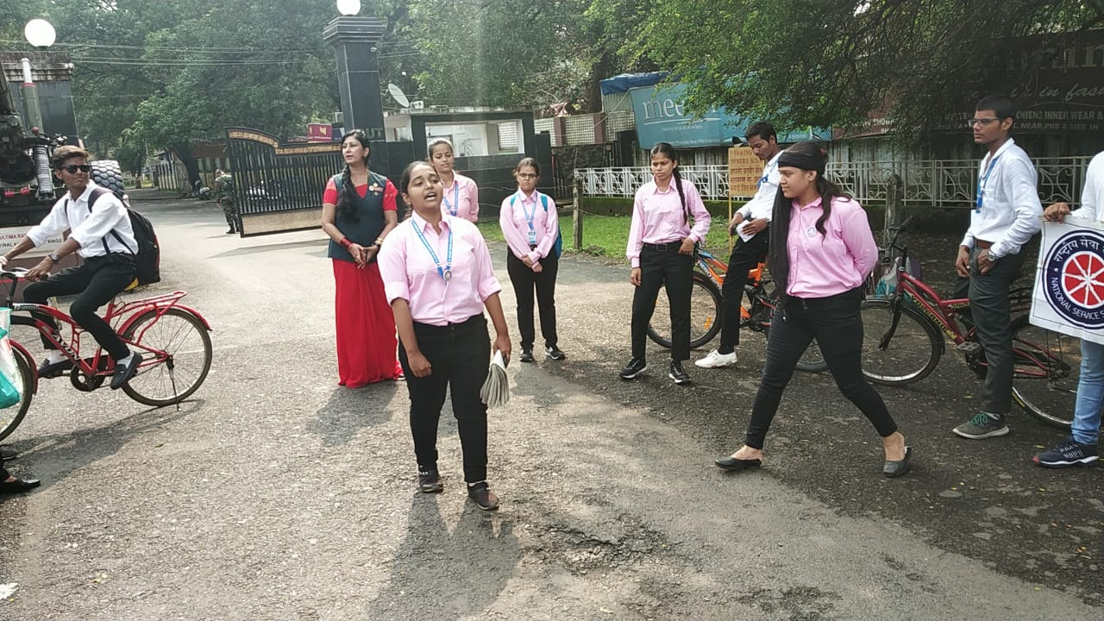
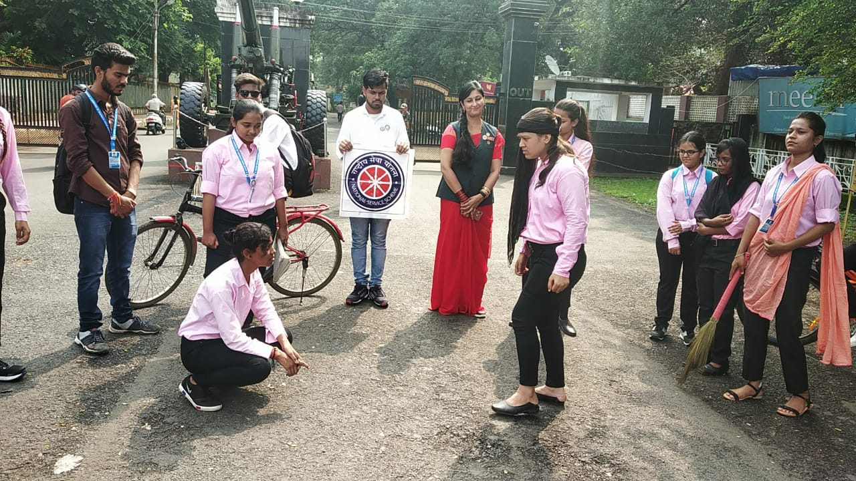
“CONCLUSION”
INDIA IS THE FASTEST DEVELOPING COUNTRY IN THE WORLD BUT STILL IT IS “DEVELOPING”. WE SHOULD CONTINUE TO MAKE THESE KINDS OF EFFORTS AND SHOULD NOT THINK OF ANY KIND OF SHAME IN DOING ANY KIND OF TASK IN VILLAGE AREA.
MAHATMA GANDHI ONCE SAID THAT IF WE WANT TO MAKE OUR COUNTRY DEVELOP, FIRST OF ALL WE SHOULD DEVELOP OUR VILLAGES.
KEEPING IN MIND THE BENEFITS OF CLEANLINESS WE ALL SHOULD TRY TO MAKE A GREEN AND CLEAN ENVIRONMENT.
JAI HIND.

